

Week-1

1)Aim:- A rocket launch system displays a count down before launch. Instead of using a loop implement the count down using a recursion ,write a recursive program to display a count down from n to 1 followed by “Launch”
Program:
'''def countdown(n):
print(n)
if n>0:
return countdown(n-1)
elif n==0:
return 0
n=int(input("Enter the number of counts:"))
countdown(n)
print("Lauch")'''

Output:
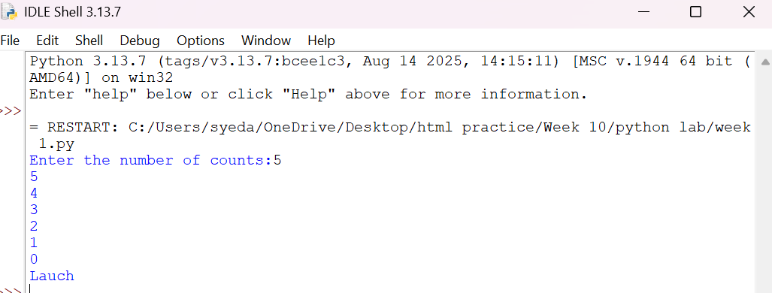
Explanation:
• The function launch(n) prints the current value of n.
• If n is greater than 0, it decreases n by 1 and calls itself recursively.
• The recursion continues until n becomes 0, which is the base case, and the function stops.

Error Table:
S.No | Error Obtained | Rectification
01. | Didn’t write the print statement after definition. | After execution I found the mistake and added it.

2)Aim: An Hr department stores employee ID in a list . Develop a recursive program to search for a given employee ID write a recursive function to search for an employee ID . Write a recursive function to search for an employee ID in a list.
Program:
def search(arr, target, i):
if i >= len(arr):
return -1
if arr[i] == target:
return i + 1
else:
return search(arr, target, i + 1)
A = [1, 2, 3, 4]
print(search(A, 2, 0)) # Output: 2Output:
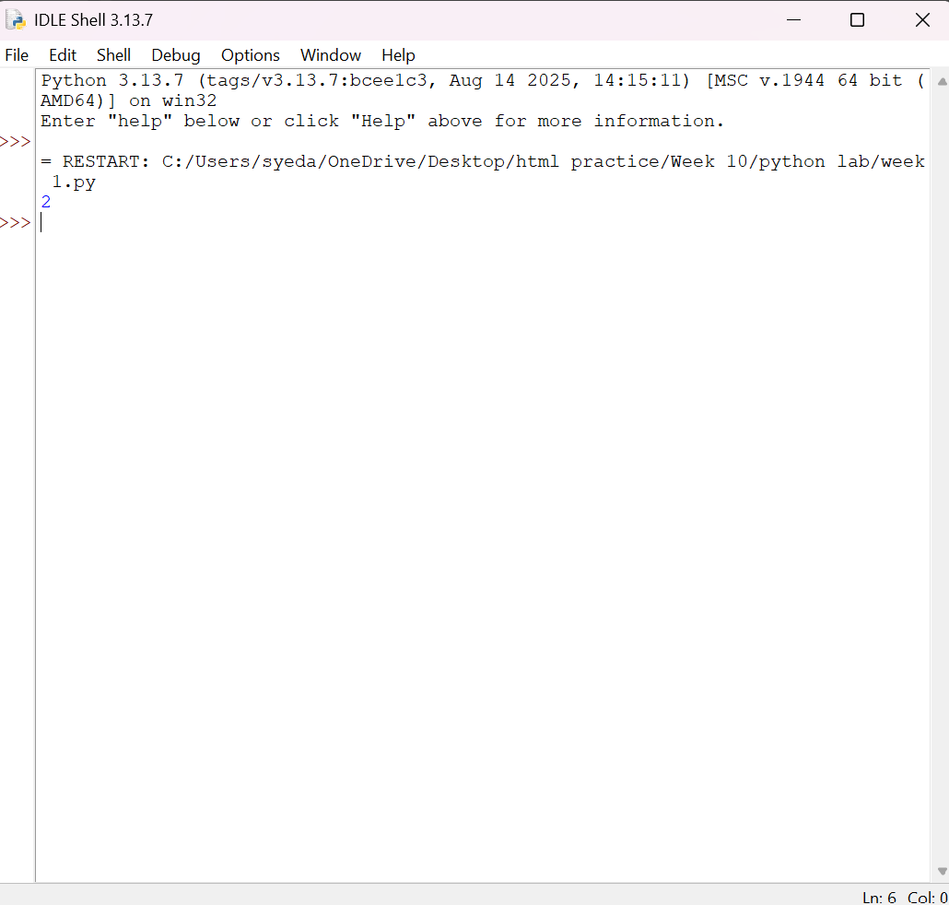
Explanation:
This program uses recursion to perform a linear search for an employee ID (or any target element) in a list.
- The function empid_Search(arr, target, n=0) is defined with three parameters:
  - arr: The list in which the search is performed.
  - target: The element to be searched.
  - n: The current index, initialized to 0.
- The statement if n == len(arr): return -1 is the base condition. It checks whether all elements in the list have been examined. If the end of the list is reached without finding the target, the function returns -1.
- The statement if arr[n] == target: return n compares the current element with the target. If they are equal, the function returns the current index where the target is found.
- If the current element does not match the target, the function calls itself recursively with the next index using return empid_Search(arr, target, n + 1).
- The list arr = [10, 20, 30, 50, 607, 809, 506] is created, and the function is called to search for the element 50.
- The returned value is stored in the variable result.
- If result is not equal to -1, the program prints the index where the element is found. Otherwise, it prints "Element not found."
Error table:
S.No | Error Obtained | Rectification
01. | Recursion Error: maximum recursion depth exceeded | Increment the index in the recursive call: return empid_Search(arr, target, n + 1).

3)Aim: This Python program uses recursion to calculate the value of pⁿ (p raised to the power n).
Program:
def CI(p,n):
if n==0:
return 1
else:
return (CI(p,n-1))*p

P=int(input("Enter the principal growth :"))
N=int(input("Enter number of years:"))
print(CI(P,N))
Output:
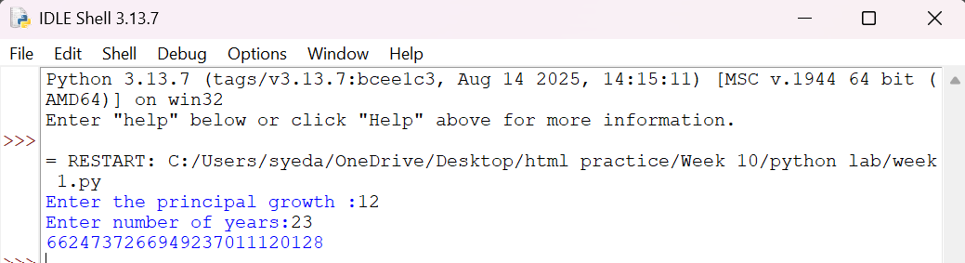
Explanation:
• The program is used to find the power of a number (pⁿ) using recursion.
• It takes two inputs from the user:
- p → Base number
- n → Exponent (power)
• The function power(p, n) is called to calculate the result.
• If the exponent n is 0, the function returns 1 because any number raised to the power 0 is
• If n is not 0, the function calls itself with n - 1 and multiplies the result by p.
• This recursive process continues until the exponent becomes 0.
• After reaching the base case, each recursive call returns its result, and the final value of pⁿ is obtained.
• The result is stored in the variable result.
• Finally, the program prints the calculated power of the given number.

Error Table:
S.No | Error Obtained | Rectification
01. | Not a int value of n we can also take float in place of int, I have taken float value to check. | By replacing int by float.

4)Aim: Write a recursive python program for fibanocci series , print first n terms series.
Program:
def fib(n):
if n==0:
return 0
elif n==1:
return 1
else:
return fib(n-1)+fib(n-2)
N=int(input("Enter the number of ele,ents of fibanocci series are to be displayed :"))
for i in range(N):
print(fib(i), end=" ")
Output:
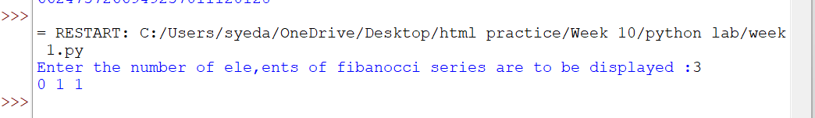

Explanation:
• The program uses a recursive function fib(n) to generate Fibonacci numbers.
• The base condition returns 0 when n = 0 and 1 when n = 1.
• For values greater than 1, the function returns the sum of the previous two Fibonacci numbers: fib(n-1) + fib(n-2).
• The user enters the number of terms (n) to be displayed.
• A for loop calls the fib() function repeatedly for each term from 0 to n-1.
• Finally, the program prints the Fibonacci series in sequence.
Error Table:
S.No | Error Obtained | Rectification
01. | No Errors obtained | -----------------------------------------

5)Aim: In a logistic company , the number of possible ways to arrange n different parcels is calculated using the factorial formula (n!) , develop a recursive program to calculate factorial of a given number.
Program:
def fact(n):
if n==0 or n==1:
return 1
else:
return fact(n-1)*n
N=int(input("Enter the number whose factorial has to be calculated :"))
print(fact(N))
Output:
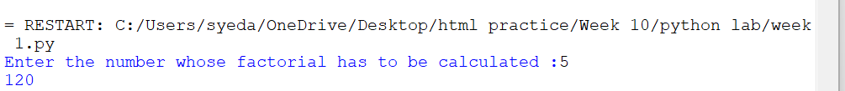
Explanation:
• The program defines a recursive function fact(n) to calculate the factorial of a number.
• The base condition checks if n <= 1. If true, it returns 1 (for factorial, 0! = 1 and 1! = 1).
• Otherwise, the function returns n * fact(n-1), multiplying the current number by the factorial of the previous number.
• The function is called with the value 6.
• Finally, the program prints the factorial of 6, which is 720.
Error Table:
S.No | Error Obtained | Rectification
01. | No Errors obatined | ---------------------------------------------------
Week-2
1)Aim:- Write a program to perform linear search on the given input.
Program:-
def linear_search(arr,target):
for i in range(len(arr)):
if arr[i]==target:
return "at position",i+1
return "element not found"
a=[]
while True:
elem=input("Enter a element(or enter stop to finish):-")
if elem.lower()=="stop":
break
a.append(int(elem))
b=int(input("Enter the element that is to be found:-"))
print(linear_search(a,b))
Output:-
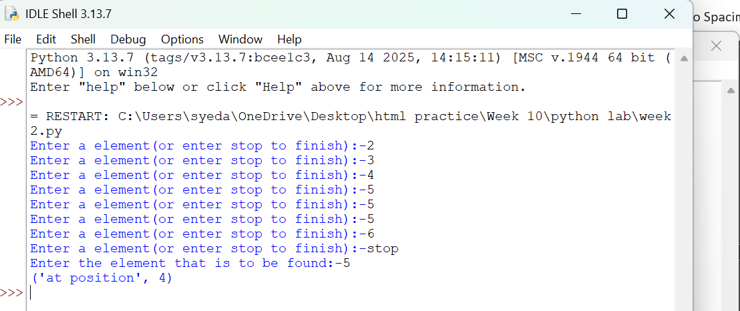
Explanation:-
This program uses a linear search technique to find a target element in a list.
- The function linear_search(arr, target) is defined with two parameters:
  - arr: The list in which the search is performed.
  - target: The element to be searched.
- A for loop is used to traverse each element of the list from index 0 to len(arr) - 1.
- The statement if arr[i] == target: compares each element of the list with the target element.
- If the element is found, the function returns "at position", i + 1, which gives the position of the element (starting from 1).
- If the loop completes without finding the element, the function returns "element not found".
- An empty list a is created, and the user is asked to input elements continuously.
- The loop continues until the user enters "stop", after which the input process ends.
- The user then enters the element to be searched, which is stored in variable b.
- The function is called using linear_search(a, b) and the result is printed.

Error Table and negatives where the code doesn’t give the effective result:-
S.No | Error Obtained | Rectification
01 | ValueError when entering non-integer input | Ensure only integer values are entered or handle using
02 | Program crashes if empty input is given before converting to int | Validate input before conversion
03 | Element not found even if list is empty | Check if list is empty before searching
04 | If duplicate elements exist, only first occurrence is returned | Modify logic if all occurrences are needed
05 | Program does not handle very large lists efficiently | Use better algorithms like binary search (for sorted lists)
2)Aim:-Write a python program to perform binary search on the given input verify by taking sorted array and unsorted array as a input:-
Program:-
def binary_search(arr,target):
low=0
high=(len(arr))-1

while low<=high:
mid=(low+high)//2
if arr[mid]==target:
return "at position",mid
elif target>arr[mid]:
low,high=mid+1,high
else:
low,high=low,mid-1
a=[]
while True:
elem=input("Enter a element(or enter stop to finish):-")
if elem.lower()=="stop":
break
a.append(int(elem))
b=int(input("Enter the element that is to be found:-"))
a.sort()
print(binary_search(a,b))
Output:-
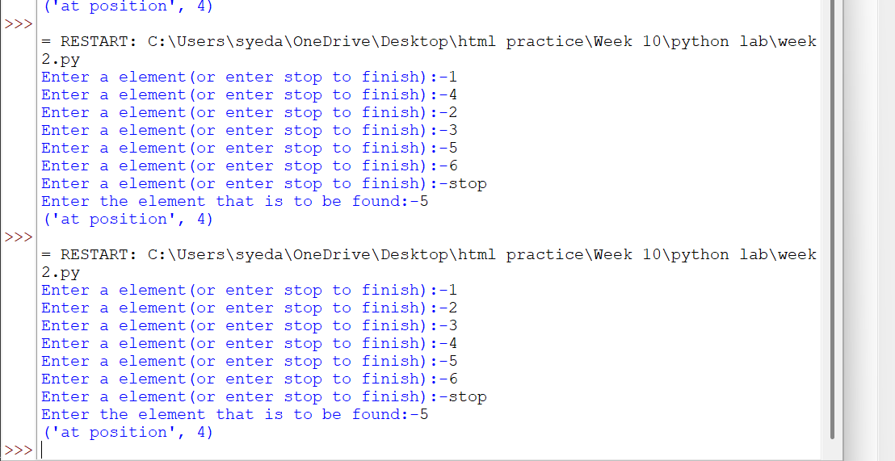
Explanation:-
This program uses the binary search technique to find a target element in a list.
- The function binary_search(arr, target) is defined to perform the search operation.
- Two variables are initialized:
  - low = 0: Represents the starting index of the list.
  - high = len(arr) - 1: Represents the last index of the list.
- A while loop runs as long as low <= high, ensuring the search space is valid.
- The middle index is calculated using mid = (low + high) // 2.
- The statement if arr[mid] == target: checks whether the middle element is equal to the target.
  - If true, the function returns "at position", mid.
- If the target is greater than the middle element (target > arr[mid]), the search continues in the right half by updating low = mid + 1.
- Otherwise, the search continues in the left half by updating high = mid - 1.
- The user inputs elements into the list a until "stop" is entered.
- The list is sorted using a.sort().
  - This ensures that even if the user enters an unsorted array, the binary search will still work correctly.
- The user enters the element to be searched, stored in variable b.
- The function is called using binary_search(a, b) and the result is printed.
Sno | Error Obtained | Rectification
01 | ValueError when non-integer input is entered | Ensure inputs are integers or use
02 | Incorrect position (0-based index returned) | Use mid + 1 if position should start from 1
03 | Program fails if list is empty | Check if list is empty before searching
04 | Binary search requires sorted array | Sorting is already handled using
05 | Element not found but no explicit message returned | Add return "element not found" after loop
06 | Output format shows tuple like ('at position', 2) | Use formatted print statement for better output
07 | Duplicate elements return only one occurrence | Modify logic if all positions are needed
08 | Sorting changes original order of elements | Inform user that positions are based on sorted list
Week-3
3a)Aim:- Write a Python program to perform Bubble Sort on a given list of elements.
Program:-
def bubble_sort(arr):
n = len(arr)
for i in range(n):
swapped = False
for j in range(0, n - i - 1):
if arr[j] > arr[j + 1]:
arr[j], arr[j + 1] = arr[j + 1], arr[j]
swapped = True
if not swapped:
break
return arr

a = []
while True:
elem = input("Enter an element (or enter stop to finish):- ")
if elem.lower() == "stop":
break
a.append(int(elem))

print("Original List:", a)
sorted_list = bubble_sort(a)
print("Sorted List: ", sorted_list)
OUTPUT:-
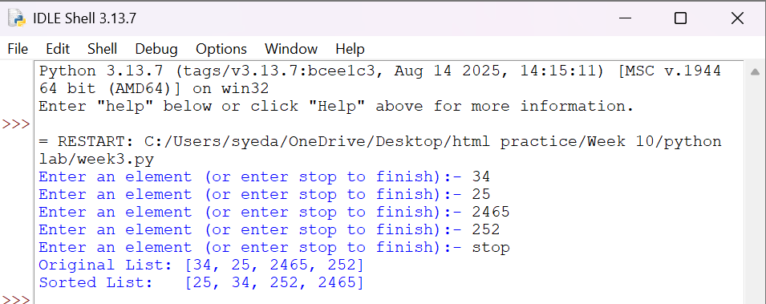
Explanation:
This program uses the Bubble Sort technique to sort elements in a list.
- The function bubble_sort(arr) is defined to sort the given list arr.
- The variable n = len(arr) stores the number of elements in the list.
- A loop runs from i = 0 to n-1, representing each pass of the sorting process.
- A variable swapped is initialized as False at the beginning of each pass.
  - It is used to check whether any swapping occurred during the pass.
- Another loop runs from j = 0 to n-i-2, comparing adjacent elements.
- The condition if arr[j] > arr[j + 1]: checks if the current element is greater than the next element.
  - If true, the elements are swapped using arr[j], arr[j + 1] = arr[j + 1], arr[j].
  - The variable swapped is set to True.
- After each pass, if no swapping occurs (swapped == False), the loop breaks early.
  - This indicates that the list is already sorted.
- The function returns the sorted list.
- The user inputs elements into the list a until "stop" is entered.
- The original list is printed, followed by the sorted list after calling bubble_sort(a).

Error Table:
S.No | Error Obtained | Rectification
01. | ValueError when non-integer input is entered | Ensure input is integer or handle using try-except
02. | Program fails for empty list (no elements entered) | Check if list is empty before sorting
03. | Sorting modifies original list | Use a copy of list if original order must be preserved
04. | Inefficient for large inputs (high time complexity) | Use faster algorithms like merge sort or quick sort
3b)
Aim:-
Write a Python program to perform Insertion Sort on a given list of elements.
Program:-
def insertion_sort(arr):
for i in range(1, len(arr)):
key = arr[i]
j = i - 1
while j >= 0 and key < arr[j]:
arr[j + 1] = arr[j]
j -= 1
arr[j + 1] = key
return arr

a = []
while True:
elem = input("Enter an element (or enter stop to finish):- ")
if elem.lower() == "stop":
break
a.append(int(elem))

print("Original List:", a)
sorted_list = insertion_sort(a)
print("Sorted List: ", sorted_list)
Output:-
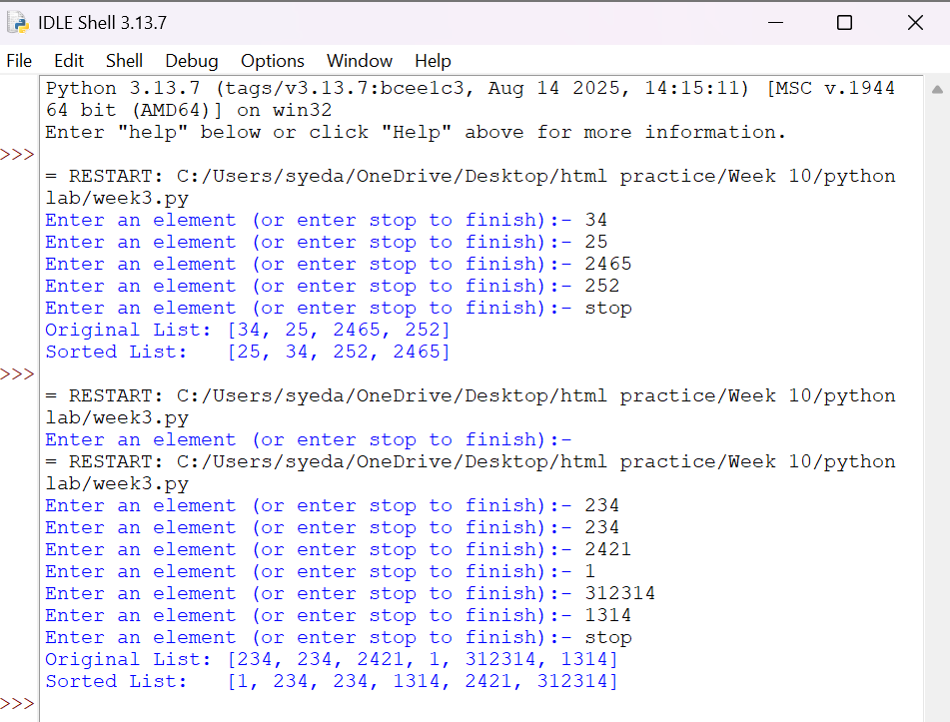
Explanation:
This program uses the Insertion Sort technique to sort elements in a list.
- The function insertion_sort(arr) is defined to sort the given list arr.
- A loop runs from i = 1 to len(arr) - 1, considering one element at a time as the key element.
- The variable key = arr[i] stores the current element to be inserted into the sorted portion of the list.
- The variable j = i - 1 points to the last element of the already sorted portion.
- A while loop runs as long as j >= 0 and key < arr[j].
  - This shifts elements one position ahead using arr[j + 1] = arr[j].
  - The value of j is decreased by 1 after each shift.
- After shifting all larger elements, the key is placed at the correct position using arr[j + 1] = key.
- This process continues until the entire list is sorted.
- The function returns the sorted list.
- The user inputs elements into the list a until "stop" is entered.
- The original list is printed, followed by the sorted list after calling insertion_sort(a).

Error Table:
S.No | Error Obtained | Rectification
01. | ValueError when non-integer input is entered | Ensure input is integer or handle using try-except
02. | Program fails for empty list | Check if list is empty before sorting
03. | Sorting modifies original list | Use a copy of list if original order must be preserved
04. | Incorrect output if comparison condition is wrong (key > arr[j]) | Ensure correct condition key < arr[j] is used
3c)
Aim:-
Write a Python program to perform Selection Sort on a given list of elements.
Program:-
def selection_sort(arr):
n = len(arr)
for i in range(n):
min_idx = i
for j in range(i + 1, n):
if arr[j] < arr[min_idx]:
min_idx = j
arr[i], arr[min_idx] = arr[min_idx], arr[i]
return arr

a = []
while True:
elem = input("Enter an element (or enter stop to finish):- ")
if elem.lower() == "stop":
break
a.append(int(elem))

print("Original List:", a)
sorted_list = selection_sort(a)
print("Sorted List: ", sorted_list)
Output:-
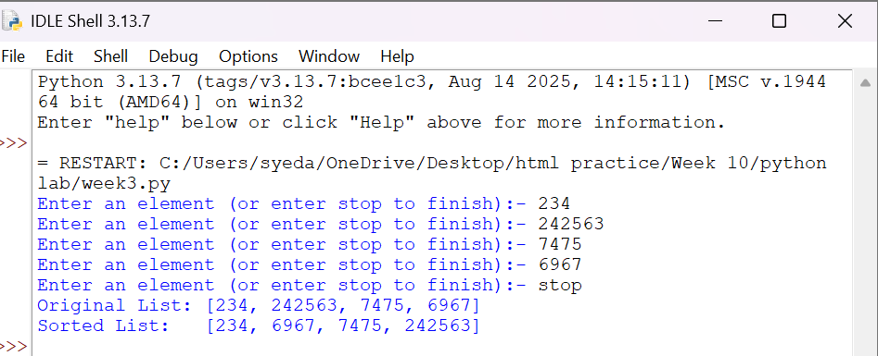
Explanation:
This program uses the Selection Sort technique to sort elements in a list.
- The function selection_sort(arr) is defined to sort the given list arr.
- The variable n = len(arr) stores the number of elements in the list.
- A loop runs from i = 0 to n-1, representing the position where the smallest element should be placed.
- The variable min_idx = i is initialized to store the index of the minimum element in the unsorted portion.
- Another loop runs from j = i + 1 to n-1, comparing elements in the unsorted part of the list.
- The condition if arr[j] < arr[min_idx]: checks if a smaller element is found.
  - If true, min_idx is updated with the index of that smaller element.
- After finding the smallest element, it is swapped with the element at position i using
arr[i], arr[min_idx] = arr[min_idx], arr[i].
- This process continues until the entire list is sorted.
- The function returns the sorted list.
- The user inputs elements into the list a until "stop" is entered.
- The original list is printed, followed by the sorted list after calling selection_sort(a).

Error Table:
S.No | Error Obtained | Rectification
01. | ValueError when non-integer input is entered | Ensure input is integer or handle using try-except
02. | Program fails for empty list | Check if list is empty before sorting
03. | Sorting modifies original list | Use a copy of list if original order must be preserved
04. | Incorrect sorting if comparison condition is wrong (arr[j] > arr[min_idx]) | Ensure correct condition arr[j] < arr[min_idx] is used

3d)
Aim:-
Write a Python program to perform Merge Sort on a given list of elements.
Program:-
def merge_sort(arr):
if len(arr) > 1:
mid = len(arr) // 2
L = arr[:mid]
R = arr[mid:]

merge_sort(L)
merge_sort(R)

i = j = k = 0

while i < len(L) and j < len(R):
if L[i] <= R[j]:
arr[k] = L[i]
i += 1
else:
arr[k] = R[j]
j += 1
k += 1

while i < len(L):
arr[k] = L[i]
i += 1
k += 1

while j < len(R):
arr[k] = R[j]
j += 1
k += 1
return arr

a = []
while True:
elem = input("Enter an element (or enter stop to finish):- ")
if elem.lower() == "stop":
break
a.append(int(elem))

print("Original List:", a)
sorted_list = merge_sort(a)
print("Sorted List: ", sorted_list)
Output:-
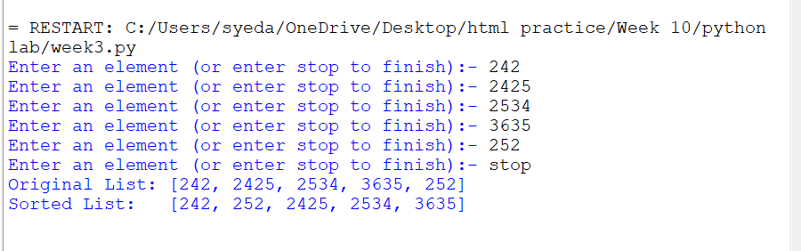
Explanation:
This program uses the Merge Sort technique to sort elements in a list using recursion.
- The function merge_sort(arr) is defined to sort the given list arr.
- The condition if len(arr) > 1: checks whether the list has more than one element.
  - If not, the list is already sorted (base case).
- The list is divided into two halves:
  - mid = len(arr) // 2 finds the middle index.
  - L = arr[:mid] stores the left half.
  - R = arr[mid:] stores the right half.
- The function recursively calls itself on both halves using merge_sort(L) and merge_sort(R).
- Three variables i, j, and k are initialized to 0:
  - i → index for left sublist
  - j → index for right sublist
  - k → index for merged list
- A while loop compares elements of L and R:
  - The smaller element is placed into arr[k].
  - Corresponding indices are incremented.
- After one sublist is exhausted, remaining elements of the other sublist are copied using two separate while loops.
- The sorted elements are merged back into the original list arr.
- The function returns the sorted list.
- The user inputs elements into the list a until "stop" is entered.
- The original list is printed, followed by the sorted list after calling merge_sort(a).

Error Table:
S.No | Error Obtained | Rectification
01. | ValueError when non-integer input is entered | Ensure input is integer or handle using try-except
02. | Program fails for empty list | Check if list is empty before sorting
03. | Incorrect merging if indices (i, j, k) are not updated properly | Ensure all indices are incremented correctly
04. | High memory usage due to creating sublists (L and R) | Use optimized in-place merge sort if required
3e)
Aim:- Write a Python program to perform Quick Sort on a given list of elements.
Program:-
def quick_sort(arr, low=0, high=None):
if high is None:
high = len(arr) - 1

if low < high:
pivot = arr[high]
i = low - 1

for j in range(low, high):
if arr[j] <= pivot:
i += 1
arr[i], arr[j] = arr[j], arr[i]
arr[i + 1], arr[high] = arr[high], arr[i + 1]
pi = i + 1
quick_sort(arr, low, pi - 1)
quick_sort(arr, pi + 1, high)

return arr

a = []
while True:
elem = input("Enter an element (or enter stop to finish):- ")
if elem.lower() == "stop":
break
a.append(int(elem))

print("Original List:", a)
sorted_list = quick_sort(a)
print("Sorted List: ", sorted_list)
Output:-
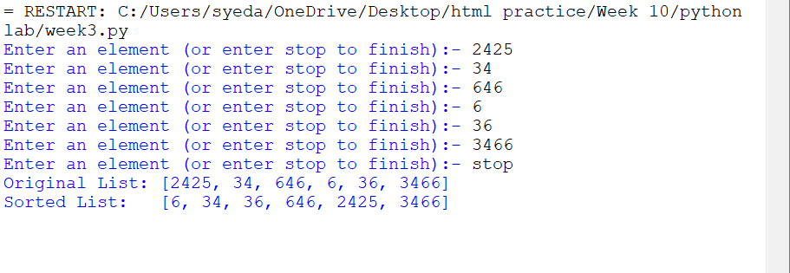

Explanation:
This program uses the Quick Sort technique to sort elements in a list using recursion.
- The function quick_sort(arr, low=0, high=None) is defined with parameters:
  - arr: The list to be sorted
  - low: Starting index (default 0)
  - high: Ending index (default last index of list)
- If high is None, it is initialized as len(arr) - 1.
- The condition if low < high: ensures that sorting is performed only when there are at least two elements.
- The last element arr[high] is chosen as the pivot.
- The variable i = low - 1 is used to track the position of smaller elements.
- A loop runs from j = low to high - 1:
  - If arr[j] <= pivot, i is incremented and elements are swapped using
arr[i], arr[j] = arr[j], arr[i].
- After the loop, the pivot is placed at its correct position using
arr[i + 1], arr[high] = arr[high], arr[i + 1].
- The pivot index pi = i + 1 divides the array into two parts.
- The function recursively sorts:
  - Left subarray → quick_sort(arr, low, pi - 1)
  - Right subarray → quick_sort(arr, pi + 1, high)
- The function returns the sorted list.
- The user inputs elements into list a until "stop" is entered.
- The original list and sorted list are printed.

Error Table:
S.No | Error Obtained | Rectification
01. | ValueError when non-integer input is entered | Ensure input is integer or handle using try-except
02. | Program fails for empty list | Check if list is empty before sorting
03. | Worst-case performance (O(n²)) for already sorted list | Use better pivot selection (e.g., middle or random pivot)
04. | Recursion depth error for very large lists | Increase recursion limit or use iterative approach
Week-4
4c)Aim:-write a python program to implement circular linked list which could perform below operations by taking input from the user
1)create linked list
2)Insert beginning
3)insert end
4)Insert at specific index
5)Delete by value
6)Delete first node
7)Delete last node
8)count number of nodes
9)Display/Traverse
10)display head to tail
11)Print the data from tail to head
10)exit
Program:
class Node:
def __init__(self, data):
self.data = data
self.next = None

class CircularLinkedList:
def __init__(self):
self.tail = None

# Create list
def create(self):
n = int(input("Enter number of elements: "))
for i in range(n):
x = int(input("Enter value: "))
self.insert_end(x)

# Insert at beginning
def insert_begin(self, data):
new = Node(data)
if self.tail is None:
self.tail = new
new.next = new
else:
new.next = self.tail.next
self.tail.next = new

# Insert at end
def insert_end(self, data):
new = Node(data)
if self.tail is None:
self.tail = new
new.next = new
else:
new.next = self.tail.next
self.tail.next = new
self.tail = new

# Insert at index
def insert_index(self, index, data):
if index < 0:
print("Invalid Index")
return
if index == 0:
self.insert_begin(data)
return
if self.tail is None:
print("Invalid Index")
return

temp = self.tail.next
for i in range(index - 1):
temp = temp.next
if temp == self.tail.next:
print("Invalid Index")
return

if temp == self.tail:
self.insert_end(data)
return

new = Node(data)
new.next = temp.next
temp.next = new

# Delete from beginning
def deleteAtBeg(self):
if self.tail is None:
print("No Data to delete")
return

if self.tail.next == self.tail:
self.tail = None
print("Deleted Value from beginning")
return

head = self.tail.next
self.tail.next = head.next
print("Deleted Value =", head.data)

# Delete from end
def deleteAtEnd(self):
if self.tail is None:
print("No Data to delete")
return

if self.tail.next == self.tail:
self.tail = None
print("Deleted Value from end")
return

temp = self.tail.next
while temp.next != self.tail:
temp = temp.next

deleted = self.tail.data
temp.next = self.tail.next
self.tail = temp
print("Deleted Value =", deleted)

# Delete by value
def delete(self, value):
if self.tail is None:
print("No Data to delete")
return

prev = self.tail
current = self.tail.next

while True:
if current.data == value:
if current == self.tail:
if current.next == current:
self.tail = None
else:
prev.next = current.next
self.tail = prev
else:
prev.next = current.next
print("Value deleted")
return
prev = current
current = current.next
if current == self.tail.next:
break

print("Value not present")

# Search value
def search(self, value):
if self.tail is None:
print("No Data")
return

temp = self.tail.next
index = 0
while True:
if temp.data == value:
print("Value found at index", index)
return
temp = temp.next
index += 1
if temp == self.tail.next:
break
print("Value not found")

# Update value
def update(self, old_value, new_value):
if self.tail is None:
print("No Data")
return

temp = self.tail.next
while True:
if temp.data == old_value:
temp.data = new_value
print("Value updated")
return
temp = temp.next
if temp == self.tail.next:
break
print("Value not found")

# Reverse list
def reverse(self):
if self.tail is None:
print("No Data")
return

values = []
temp = self.tail.next
while True:
values.append(temp.data)
temp = temp.next
if temp == self.tail.next:
break

self.tail = None
for value in reversed(values):
self.insert_end(value)
print("List reversed")

# Display list
def display(self):
if self.tail is None:
print("No Data")
return

temp = self.tail.next
while True:
print(temp.data, end=" -> ")
temp = temp.next
if temp == self.tail.next:
break
print("head")

# Count nodes
def count(self):
if self.tail is None:
return 0

c = 1
temp = self.tail.next
while temp != self.tail:
c += 1
temp = temp.next
return c
# Display from head to tail (already similar to display)
def display_head_to_tail(self):
if self.tail is None:
print("No Data")
return

temp = self.tail.next # head
while True:
print(temp.data, end=" -> ")
temp = temp.next
if temp == self.tail.next:
break
print("head")

# Display from tail to head
def display_tail_to_head(self):
if self.tail is None:
print("No Data")
return

values = []
temp = self.tail.next # start from head

while True:
values.append(temp.data)
temp = temp.next
if temp == self.tail.next:
break

# print in reverse order
for val in reversed(values):
print(val, end=" -> ")
print("tail")

# Menu-driven program
cll = CircularLinkedList()

while True:
print("\n1. Create Linked List")
print("2. Insert Beginning")
print("3. Insert End")
print("4. Insert at Index")
print("5. Delete by Value")
print("6. Delete First Node")
print("7. Delete Last Node")
print("8. Count Nodes")
print("9. Display")
print("10. Search Value")
print("11. Update Value")
print("12. Reverse List")
print("13. Exit")
print("14. Display Head to Tail")
print("15. Display Tail to Head")

ch = int(input("Choice: "))

if ch == 1:
cll.create()
elif ch == 2:
x = int(input("Value: "))
cll.insert_begin(x)
elif ch == 3:
x = int(input("Value: "))
cll.insert_end(x)
elif ch == 4:
idx = int(input("Index: "))
x = int(input("Value: "))
cll.insert_index(idx, x)
elif ch == 5:
x = int(input("Delete value: "))
cll.delete(x)
elif ch == 6:
cll.deleteAtBeg()
elif ch == 7:
cll.deleteAtEnd()
elif ch == 8:
print("Number of nodes =", cll.count())
elif ch == 9:
cll.display()
elif ch == 10:
x = int(input("Search value: "))
cll.search(x)
elif ch == 11:
old = int(input("Old value: "))
new = int(input("New value: "))
cll.update(old, new)
elif ch == 12:
cll.reverse()
elif ch == 14:
cll.display_head_to_tail()
elif ch == 15:
cll.display_tail_to_head()
elif ch == 13:
break
else:
print("Invalid choice")

if __name__ == "__main__":
pass
Output:
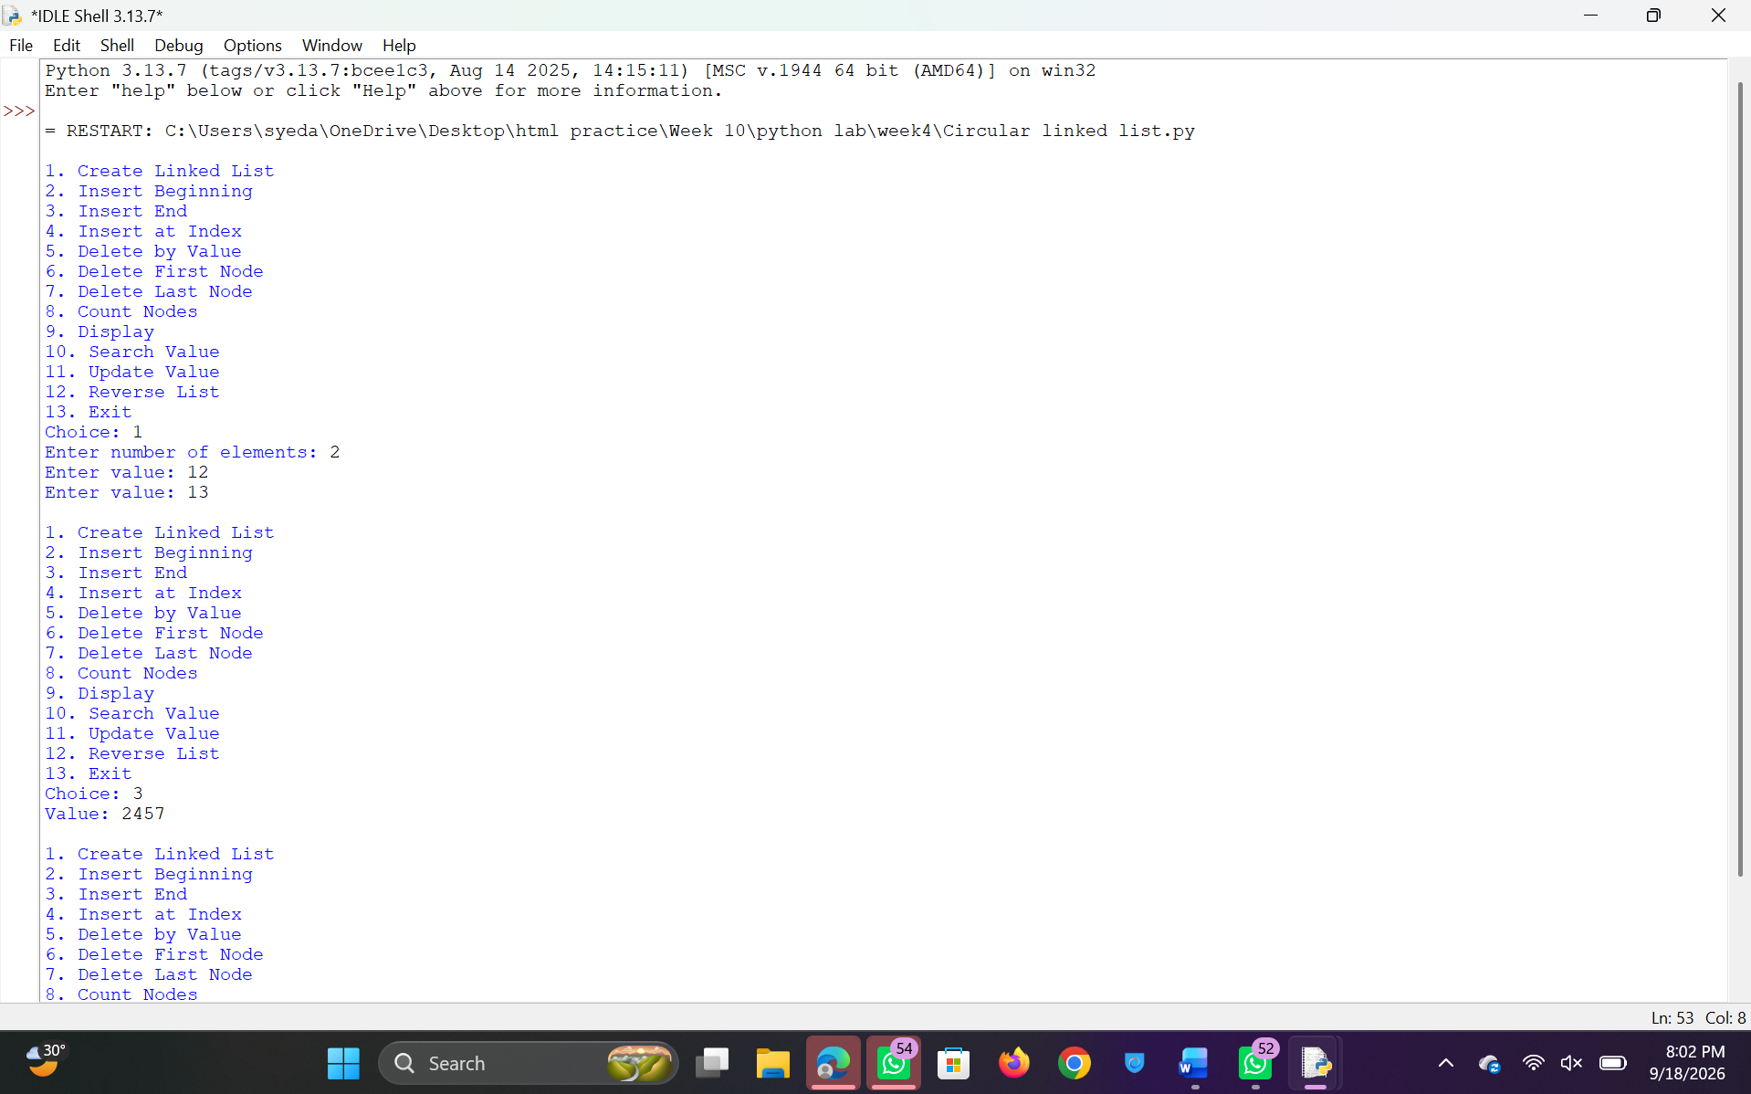
Explanation:
This program implements a Circular Linked List using Python and performs various operations like insertion, deletion, searching, updating, reversing, and displaying elements using a menu-driven approach.
- Node Class Creation:
The class Node is defined with two attributes:
  - data → stores the value
  - next → stores the reference to the next node
- Circular Linked List Initialization:
The class CircularLinkedList is defined with a tail pointer.
  - tail.next always points to the head node, maintaining circular nature.
- Creating the List:
The function create() takes input from the user and inserts elements at the end using insert_end().
- Insertion at Beginning:
  - If list is empty → new node points to itself.
  - Otherwise → new node is inserted before head and tail is updated accordingly.
- Insertion at End:
  - New node is added after tail.
  - Tail pointer is updated to the new node.
  - Circular link is maintained.
- Insertion at Index:
  - Validates index.
  - Traverses list to required position.
  - Inserts node at specified position.
  - Handles edge cases like insertion at beginning or end.
- Deletion at Beginning:
  - If only one node → list becomes empty.
  - Otherwise → head node is removed and tail points to new head.
- Deletion at End:
  - Traverses list to find node before tail.
  - Updates tail and maintains circular link.
- Deletion by Value:
  - Traverses list to find the given value.
  - Deletes node by adjusting previous node’s pointer.
  - Handles deletion of tail and single-node list.
- Search Operation:
  - Traverses the list and compares each node’s data.
  - Displays index if value is found.
- Update Operation:
  - Searches for given value.
  - Replaces it with new value if found.
- Reverse Operation:
  - Stores all node values in a list.
  - Rebuilds the linked list in reverse order.
- Display Operation:
  - Traverses from head to tail.
  - Prints elements in circular format ending with “head”.
- Count Operation:
  - Traverses the list and counts number of nodes.
- Menu-Driven Execution:
  - User selects operations using menu choices.
  - Corresponding functions are called based on input.
This program adds two additional display operations for a Circular Linked List.
10. Display Head to Tail:
- The function display_head_to_tail() prints elements starting from the head node.
- The head node is accessed using self.tail.next.
- A temporary pointer temp is used to traverse the list.
- A loop runs until it reaches the head again (circular condition).
- Each node’s data is printed in sequence.
- Finally, "head" is printed to indicate circular linkage.

11. Display Tail to Head:
- The function display_tail_to_head() prints elements from tail to head.
- Since singly circular linked list cannot be traversed backward directly, values are first stored in a list.
- The list is traversed from head using a temporary pointer.
- All node values are appended into a Python list values.
- The list is then reversed using reversed() function.
- Elements are printed in reverse order, representing tail-to-head traversal.
- Finally, "tail" is printed to indicate reverse direction.

Error Table:
S.No | Error Obtained | Rectification
01. | ValueError when non-integer input is entered | Use try-except to handle invalid input
02. | Invalid index during insertion | Check index range before inserting
03. | Deletion on empty list | Add condition to check if list is empty
04. | Infinite loop if circular link is broken | Ensure tail.next always points to head
05. | Value not found during delete/search/update | Display proper message if value not present
06. | Incorrect tail update during deletion | Ensure tail is updated correctly when last node is removed
07. | High memory usage in reverse function | Use pointer-based reversal instead of extra list
08. | Program crashes on invalid menu choice | Handle invalid choice using else condition
4b)Aim:-write a python program to implement doubly linked list which could perform below operations by taking input from the user
1)create linked list
2)Insert beginning
3)insert end
4)Insert at specific index
5)Delete by value
6)Delete first node
7)Delete last node
8)count number of nodes
9)Display/Traverse
10)exit
Program:-
class Node:
def __init__(self, data):
self.data = data
self.previous = None
self.next = None

class DoublyLinkedList:
def __init__(self):
self.head = None
self.tail = None

# Create list
def create(self):
n = int(input("Enter number of elements: "))
for i in range(n):
x = int(input("Enter value: "))
self.insert_end(x)

# Insert at beginning
def insert_begin(self, data):
new = Node(data)
if self.head is None:
self.head = self.tail = new
else:
new.next = self.head
self.head.previous = new
self.head = new

# Insert at end
def insert_end(self, data):
new = Node(data)
if self.head is None:
self.head = self.tail = new
else:
new.previous = self.tail
self.tail.next = new
self.tail = new

# Insert at index
def insert_index(self, index, data):
if index < 0:
print("Invalid Index")
return
if index == 0:
self.insert_begin(data)
return

if self.head is None:
print("Invalid Index")
return

temp = self.head
for i in range(index):
if temp is None:
print("Invalid Index")
return
temp = temp.next

if temp is None:
self.insert_end(data)
return

new = Node(data)
new.previous = temp.previous
new.next = temp
if temp.previous is not None:
temp.previous.next = new
else:
self.head = new
temp.previous = new

# Delete from beginning
def deleteAtBeg(self):
if self.head is None:
print("No Data to delete")
return

if self.head == self.tail:
self.head = self.tail = None
else:
self.head = self.head.next
self.head.previous = None
print("Deleted Value from beginning")

# Delete from end
def deleteAtEnd(self):
if self.tail is None:
print("No Data to delete")
return

if self.head == self.tail:
self.head = self.tail = None
else:
self.tail = self.tail.previous
self.tail.next = None
print("Deleted Value from end")

# Delete by value
def delete(self, value):
if self.head is None:
print("No Data to delete")
return

temp = self.head
while temp is not None and temp.data != value:
temp = temp.next

if temp is None:
print("Value not present")
return

if temp == self.head:
self.deleteAtBeg()
return

if temp == self.tail:
self.deleteAtEnd()
return

temp.previous.next = temp.next
temp.next.previous = temp.previous
print("Value deleted")

# Delete by index
def delete_at_index(self, index):
if self.head is None:
print("No Data to delete")
return

if index < 0:
print("Invalid Index")
return

temp = self.head
for i in range(index):
if temp is None:
print("Invalid Index")
return
temp = temp.next

if temp is None:
print("Invalid Index")
return

if temp == self.head:
self.deleteAtBeg()
return

if temp == self.tail:
self.deleteAtEnd()
return

temp.previous.next = temp.next
temp.next.previous = temp.previous
print("Deleted Value at index", index)

# Search value
def search(self, value):
temp = self.head
index = 0
while temp is not None:
if temp.data == value:
print("Value found at index", index)
return
temp = temp.next
index += 1
print("Value not found")

# Update value
def update(self, old_value, new_value):
temp = self.head
while temp is not None:
if temp.data == old_value:
temp.data = new_value
print("Value updated")
return
temp = temp.next
print("Value not found")

# Reverse list
def reverse(self):
if self.head is None:
print("No Data")
return

current = self.head
while current is not None:
current.previous, current.next = current.next, current.previous
self.head = current
current = current.previous

self.head, self.tail = self.tail, self.head
print("List reversed")

# Display list
def display(self):
if self.head is None:
print("No Data")
return

temp = self.head
while temp:
print(temp.data, end=" <-> ")
temp = temp.next
print("None")

# Count nodes
def count(self):
c = 0
temp = self.head
while temp:
c += 1
temp = temp.next
return c

# Menu-driven program
dll = DoublyLinkedList()

while True:
print("\n1. Create Linked List")
print("2. Insert Beginning")
print("3. Insert End")
print("4. Insert at Index")
print("5. Delete by Value")
print("6. Delete First Node")
print("7. Delete Last Node")
print("8. Count Nodes")
print("9. Display")
print("10. Search Value")
print("11. Update Value")
print("12. Reverse List")
print("13. Exit")

ch = int(input("Choice: "))

if ch == 1:
dll.create()
elif ch == 2:
x = int(input("Value: "))
dll.insert_begin(x)
elif ch == 3:
x = int(input("Value: "))
dll.insert_end(x)
elif ch == 4:
idx = int(input("Index: "))
x = int(input("Value: "))
dll.insert_index(idx, x)
elif ch == 5:
x = int(input("Delete value: "))
dll.delete(x)
elif ch == 6:
dll.deleteAtBeg()
elif ch == 7:
dll.deleteAtEnd()
elif ch == 8:
print("Number of nodes =", dll.count())
elif ch == 9:
dll.display()
elif ch == 10:
x = int(input("Search value: "))
dll.search(x)
elif ch == 11:
old = int(input("Old value: "))
new = int(input("New value: "))
dll.update(old, new)
elif ch == 12:
dll.reverse()
elif ch == 13:
break
else:
print("Invalid choice")

if __name__ == "__main__":
pass
Output:-
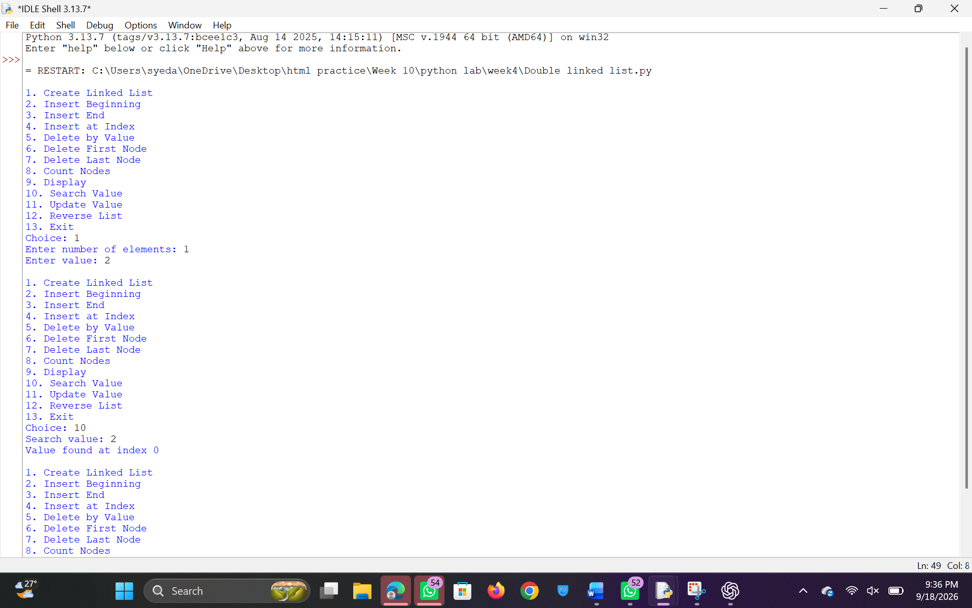
Explanation:
This program implements a Doubly Linked List using Python and performs operations such as insertion, deletion, searching, updating, reversing, and displaying elements using a menu-driven approach.
- Node Class Creation:
The class Node contains:
  - data → stores value
  - previous → points to previous node
  - next → points to next node
- Doubly Linked List Initialization:
The class DoublyLinkedList maintains two pointers:
  - head → first node
  - tail → last node
- Creating the List:
The function create() takes input from the user and inserts elements at the end using insert_end().
- Insertion at Beginning:
  - If list is empty → new node becomes head and tail.
  - Otherwise → new node is linked before head and head is updated.
- Insertion at End:
  - New node is added after tail.
  - Tail pointer is updated accordingly.
- Insertion at Index:
  - Validates index.
  - Traverses to required position.
  - Inserts node between two nodes by updating both previous and next pointers.
- Deletion at Beginning:
  - If only one node → list becomes empty.
  - Otherwise → head is moved to next node and previous pointer is set to None.
- Deletion at End:
  - If only one node → list becomes empty.
  - Otherwise → tail is moved to previous node and next pointer is set to None.
- Deletion by Value:
  - Searches for the node containing the value.
  - Adjusts both previous and next pointers to remove the node.
- Deletion by Index:
  - Traverses to given index.
  - Deletes node by updating adjacent node links.
- Search Operation:
  - Traverses from head to tail.
  - Prints index if value is found.
- Update Operation:
  - Searches for a value.
  - Replaces it with new value.
- Reverse Operation:
  - Swaps previous and next pointers for each node.
  - Swaps head and tail pointers at the end.
- Display Operation:
  - Traverses from head to tail.
  - Prints elements in forward direction.
- Count Operation:
  - Traverses list and counts number of nodes.
- Menu-Driven Execution:
  - User selects operation.
  - Corresponding function is executed.

Error Table:
S.No | Error Obtained | Rectification
01. | ValueError for invalid input | Use try-except for input handling
02. | Invalid index during insertion/deletion | Validate index before operation
03. | Deletion on empty list | Check if head is None
04. | Incorrect pointer updates | Ensure both next and previous are updated
05. | Value not found during operations | Display proper message
06. | Infinite loop due to incorrect linking | Maintain proper next and previous connections
07. | Reverse not working correctly | Ensure pointer swapping is done properly
08. | Traversal error in reverse display | Use previous pointer correctly
4a)Aim:-write a python program to implement Single linked list which could perform below operations by taking input from the user
1)create linked list
2)Insert beginning
3)insert end
4)Insert at specific index
5)Delete by value
6)Delete first node
7)Delete last node
8)count number of nodes
9)Display/Traverse
10)exit
Program:-

class Node:
def __init__(self, data):
self.data = data
self.next = None

class SinglyLinkedList:
def __init__(self):
self.head = None

# Create list
def create(self):
n = int(input("Enter number of elements: "))
for i in range(n):
x = int(input("Enter value: "))
new = Node(x)

if self.head is None:
self.head = new
else:
temp = self.head
while temp.next:
temp = temp.next
temp.next = new

# Insert at beginning
def insert_begin(self, data):
new = Node(data)
new.next = self.head
self.head = new

# Insert at end
def insert_end(self, data):
new = Node(data)

if self.head is None:
self.head = new
else:
temp = self.head
while temp.next:
temp = temp.next
temp.next = new

# Insert at index
def insert_index(self, index, data):
if index == 0:
self.insert_begin(data)
return
elif index > self.count() or index < 0:
print("Invalid Index")
return

new = Node(data)
temp = self.head

for i in range(index - 1):
temp = temp.next

new.next = temp.next
temp.next = new

# Delete from beginning
def deleteAtBeg(self):
if self.head is None:
print("No Data to delete")
else:
temp = self.head
self.head = temp.next
print("Deleted Value =", temp.data)

# Delete from end
def deleteAtEnd(self):
if self.head is None:
print("No Data to delete")
elif self.head.next is None:
self.head = None
else:
temp = self.head
while temp.next.next:
temp = temp.next
temp.next = None

# Delete by value
def delete(self, value):
if self.head is None:
print("No Data to delete")
return

temp = self.head

if temp and temp.data == value:
self.head = temp.next
print("Value deleted")
return

while temp.next and temp.next.data != value:
temp = temp.next

if temp.next is None:
print("Value not present")
else:
temp.next = temp.next.next
print("Value deleted")

# Display list
def display(self):
if self.head is None:
print("No Data")
else:
temp = self.head
while temp:
print(temp.data, end=" -> ")
temp = temp.next
print("None")

# Count nodes
def count(self):
c = 0
temp = self.head
while temp:
c += 1
temp = temp.next
return c

# Menu-driven program
sll = SinglyLinkedList()

while True:
print("\n1. Create Linked List")
print("2. Insert Beginning")
print("3. Insert End")
print("4. Insert at Index")
print("5. Delete by Value")
print("6. Delete First Node")
print("7. Delete Last Node")
print("8. Count Nodes")
print("9. Display")
print("10. Exit")

ch = int(input("Choice: "))

if ch == 1:
sll.create()

elif ch == 2:
x = int(input("Value: "))
sll.insert_begin(x)

elif ch == 3:
x = int(input("Value: "))
sll.insert_end(x)

elif ch == 4:
idx = int(input("Index: "))
x = int(input("Value: "))
sll.insert_index(idx, x)

elif ch == 5:
x = int(input("Delete value: "))
sll.delete(x)

elif ch == 6:
sll.deleteAtBeg()

elif ch == 7:
sll.deleteAtEnd()

elif ch == 8:
print("Number of nodes =", sll.count())

elif ch == 9:
sll.display()

elif ch == 10:
break

else:
print("Invalid choice")
Output:-
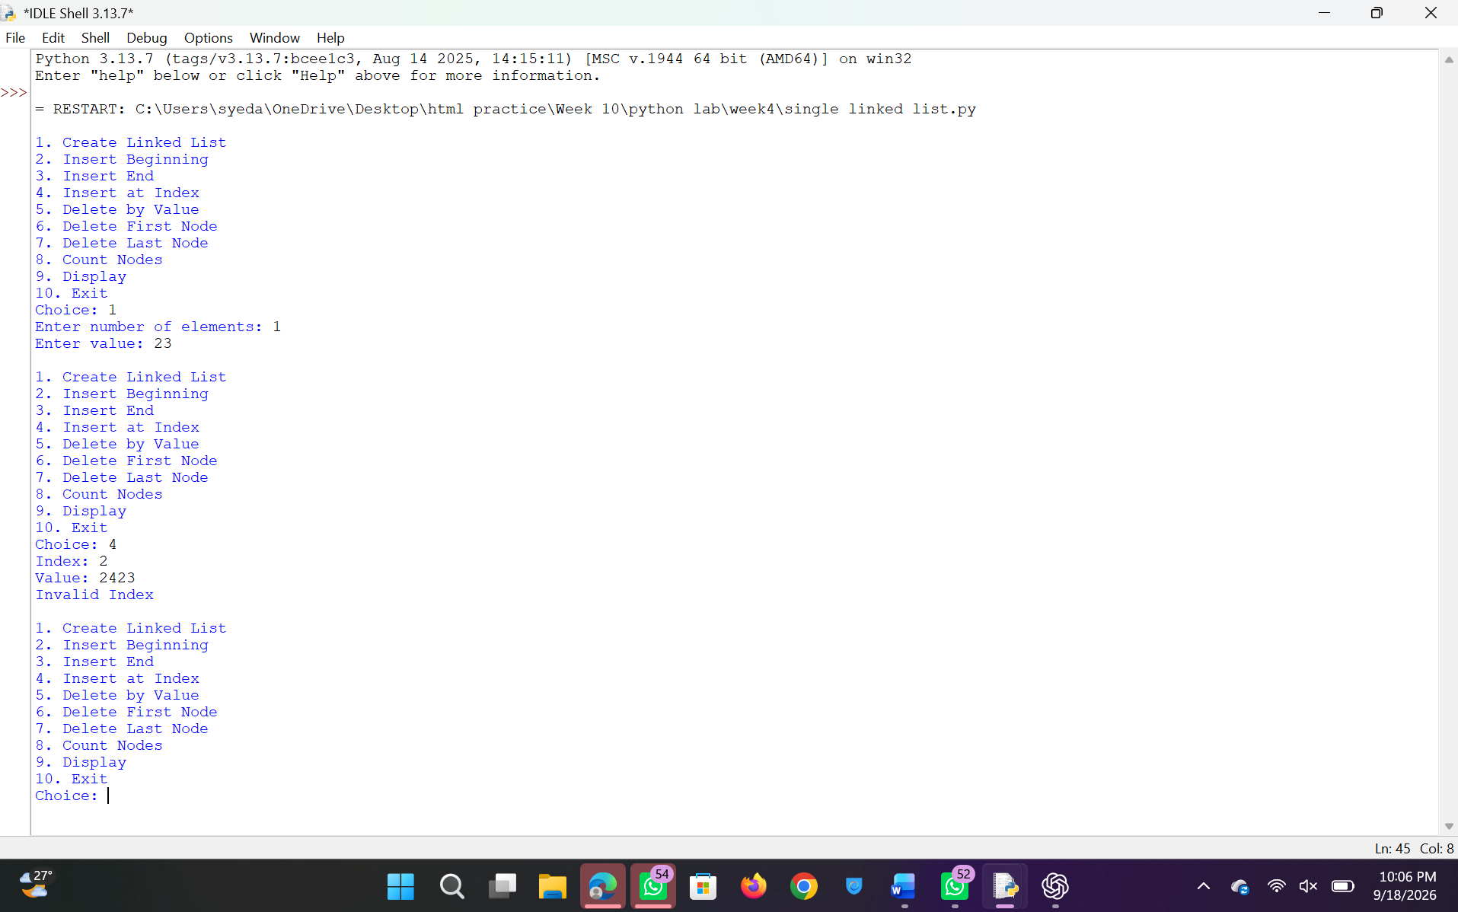
Explanation:
This program implements a Singly Linked List using Python and performs operations such as insertion, deletion, and traversal using a menu-driven approach.
- Node Class Creation:
The class Node is defined with:
  - data → stores the value
  - next → stores reference to the next node
- Singly Linked List Initialization:
The class SinglyLinkedList contains a pointer head which points to the first node of the list.
- Creating the List:
The function create() takes input from the user and creates nodes dynamically.
  - If list is empty → new node becomes head
  - Otherwise → traverse till last node and attach new node
- Insertion at Beginning:
  - A new node is created
  - Its next points to current head
  - Head is updated to new node
- Insertion at End:
  - Traverse till last node
  - Attach new node at the end
- Insertion at Index:
  - If index = 0 → insert at beginning
  - If index is invalid → display error
  - Otherwise → traverse to position and insert node
- Deletion at Beginning:
  - If list is empty → display message
  - Otherwise → head is moved to next node
- Deletion at End:
  - If only one node → list becomes empty
  - Otherwise → traverse till second last node and remove last node
- Deletion by Value:
  - If value is at head → update head
  - Otherwise → traverse list to find value
  - Adjust links to remove node
- Display Operation:
  - Traverse from head to end
  - Print each node’s data
- Count Operation:
  - Traverse list and count number of nodes
- Menu-Driven Execution:
  - User selects operation
  - Corresponding function is executed

Error Table:
S.No | Error Obtained | Rectification
01. | ValueError for invalid input | Use try-except for input
02. | Invalid index during insertion | Check index range before inserting
03. | Deletion on empty list | Check if head is None
04. | Value not found during deletion | Display proper message
05. | Infinite loop due to wrong linking | Ensure next pointers are correct
06. | Reverse display not possible directly | Use auxiliary list for reverse traversal
07. | Program crash for negative index | Validate index before operation
WEEK – 5

5)aim:-
write a python program to implement a stack using an array, linked list. Also
implement the stack operation such as push, pop, peep and also display the stack elements

Program:-
class StackArray:
def init(self, size):
self.size = size self.stack = [None] * size self.top = -1
def push(self, item):
if self.top == self.size - 1:
print("Stack Overflow")
else:
self.top += 1
self.stack[self.top] = item
print(item, "pushed into the stack")
def pop(self):
if self.top == -1:
print("Stack Underflow")
else:
item = self.stack[self.top]
self.stack[self.top] = None
self.top -= 1
print(item, "popped from the stack")
def peek(self):
if self.top == -1:
print("Stack is empty")
else:
print("Top element:", self.stack[self.top])
def display(self):
if self.top == -1:
print("Stack is empty")
else:
print("Stack elements (top to bottom):")
for i in range(self.top, -1, -1):
print(self.stack[i])
size = int(input("Enter size of stack: ")) s = StackArray(size)
while True: print("\n--- STACK USING ARRAY ---") print("1. Push") print("2. Pop") print("3. Peek") print("4. Display") print("5. Exit")
choice = int(input("Enter your choice: "))
if choice == 1:
item = int(input("Enter element to push: "))
s.push(item)
elif choice == 2:
s.pop()
elif choice == 3:
s.peek()
elif choice == 4:
s.display()
elif choice == 5:
print("Exiting program...")
break
else:
print("Invalid choice. Try again.")
Output:
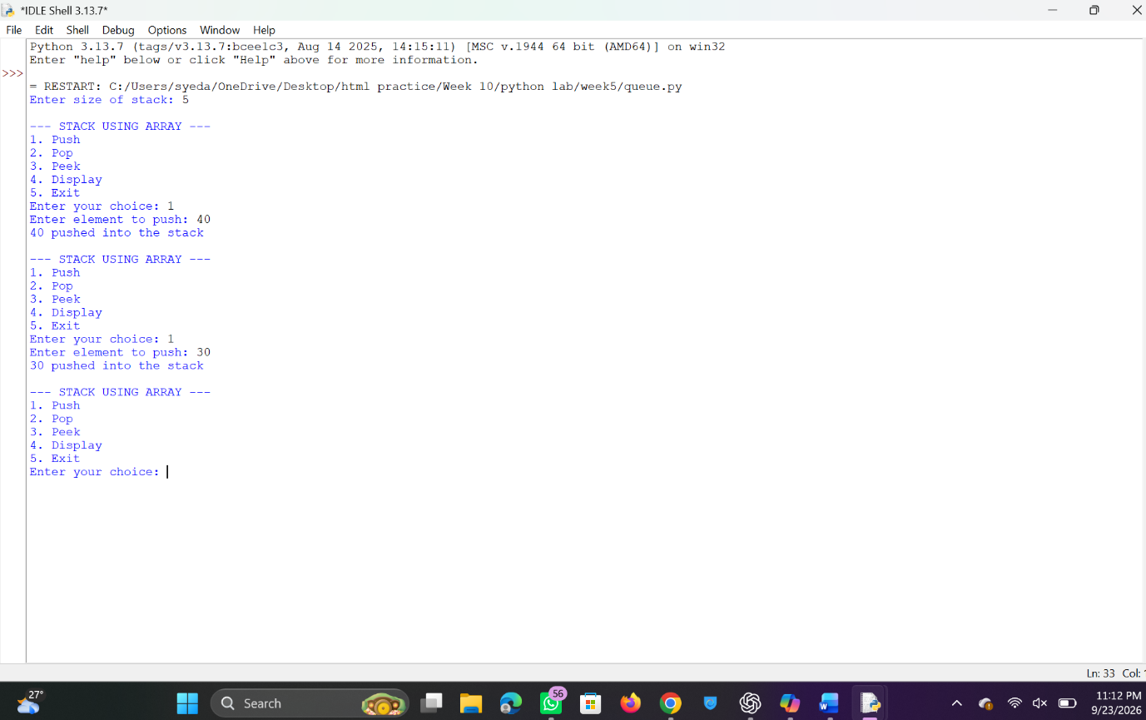
Stack using linkedlist
Program:
class Node:
def init(self, data):
self.data = data self.next = None
class StackLinkedList: def init(self): self.top = None
def push(self, data):
new_node = Node(data)
new_node.next = self.top
self.top = new_node
print(data, "pushed into the stack")
def pop(self):
if self.top is None:
print("Stack Underflow")
else:
popped = self.top.data
self.top = self.top.next
print(popped, "popped from the stack")
def peek(self):
if self.top is None:
print("Stack is empty")
else:
print("Top element:", self.top.data)
def display(self):
if self.top is None:a
print("Stack is empty")
else:
print("Stack elements (top to bottom):")
temp = self.top
while temp:
print(temp.data)
temp = temp.next
s = StackLinkedList()
while True: print("\n--- STACK USING LINKED LIST ---") print("1. Push") print("2. Pop") print("3. Peek") print("4. Display") print("5. Exit")
choice = int(input("Enter your choice: "))
if choice == 1:
item = int(input("Enter element to push: "))
s.push(item)
elif choice == 2:
s.pop()
elif choice == 3:
s.peek()
elif choice == 4:
s.display()
elif choice == 5:
print("Exiting program...")
break
else:
print("Invalid choice. Try again.")
Output:
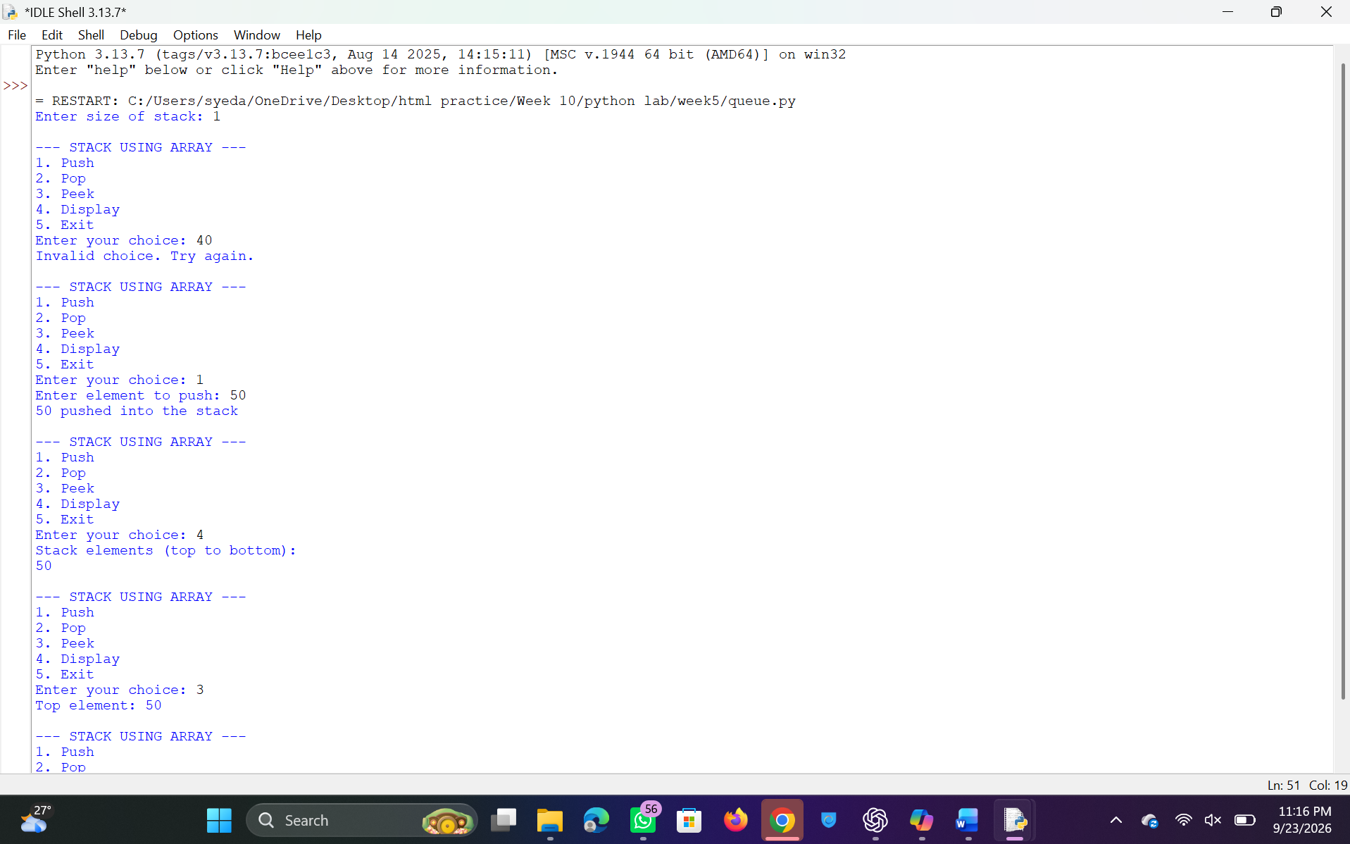
Explanation:
This program implements a stack using an array and provides basic stack operations.
- A class StackArray is defined with a constructor __init__(self, size) to initialize:
  - size: Maximum size of the stack
  - stack: A list of fixed size initialized with None
  - top = -1: Indicates that the stack is initially empty
- The push(self, item) method is used to insert an element into the stack:
  - It checks if top == size - 1 (stack full), then displays "Stack Overflow"
  - Otherwise, top is incremented and the element is inserted
- The pop(self) method is used to remove an element from the stack:
  - It checks if top == -1 (stack empty), then displays "Stack Underflow"
  - Otherwise, the top element is removed and top is decremented
- The peek(self) method displays the top element of the stack:
  - If the stack is empty, it displays "Stack is empty"
  - Otherwise, it prints the element at index top
- The display(self) method shows all elements in the stack:
  - If the stack is empty, it displays "Stack is empty"
  - Otherwise, elements are printed from top to bottom using a loop
- In the driver code:
  - The user enters the size of the stack
  - A menu-driven loop allows the user to perform operations: Push, Pop, Peek, Display, or Exit
- Based on user choice, the corresponding stack operation is executed until the user chooses to exit.

Error Table:
S.No | Error Obtained | Rectification
01. | ValueError when non-integer input is entered | Ensure valid integer input or use try-except
02. | Stack Overflow when pushing beyond capacity | Check size before pushing (already handled)
03. | Stack Underflow when popping from empty stack | Check if stack is empty before popping (already handled)
04. | Invalid menu choice entered | Validate input and prompt user again

